Terms of Payment
The Terms of payment page is used to define how the due date will be calculated.
Follow these steps to set up terms of payments
- Go to Modules > Accounts payable > Payment setup > Terms of payment.
- Select New.
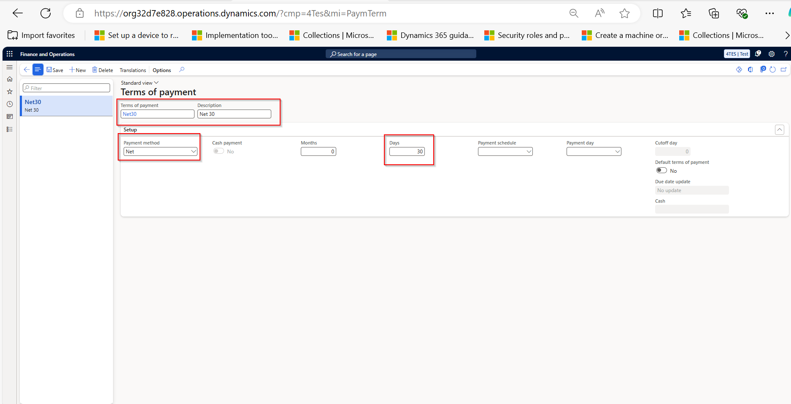

In the Terms of payment field, type a value. i.e NET30 (Mandatory)
- In the Description field, type a value.
- In the Days field, enter a number. The number entered here will be used to add to the due date, or to the end of the period identified in the Payment method. For example, if you select Net, the number will be added to the due date. If you select Current month, it will add the number to the last day of the current month to calculate the due date.
- Select Save.
- Close the page.

